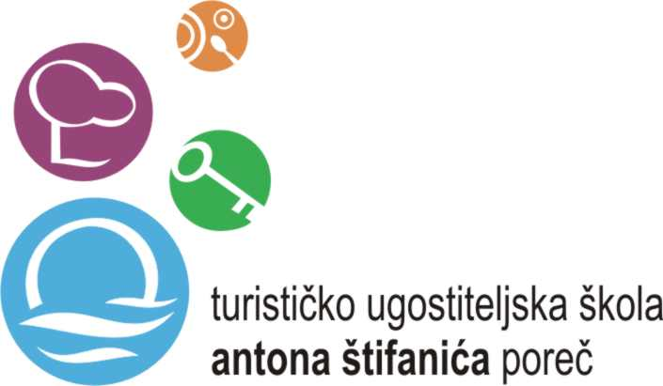

ERASMUS+ „YES EUROPE“ PROJECT
Project Meeting in Porec, Croatia 24.09.2017-30.09.2017

Guest Teachers | 14
Guest Students | 22
TOTAL Number of Guests | 36
Host Students | 14
Host teachers | 10
TOTAL number of participants | 60

Sunday 24.9.2017
Individual arrival of the project meeting participants at the Hotel Valamar Diamant (teachers and students).
Host students will wait for their student guests at the Hotel Valamar Diamant.

Monday 25.9.2017

8:00 taxi van departure from Hotel Diamant (teachers)

9:00 Welcome ceremony at Villa Polesini- Porec
9:00-9:15Welcome Speech- Vesna Baranasic Principal
Welcome Speech- Tatjana Gulic Pisarevic- School project coordinator

09:15-09:30 Presentation of the Region Istria- The heart of tourism of Croatia
09:30-09:45 Presentation of Porec as a torism destination- Mr Nenad Velenik- Head Manager of Porec Tourism Board
09:45-10:00 Presentation of the School System in Croatia- Mrs Vesna Baranasic

10:00 Coffee Break

10:30 Presentation of the project „Young people working in tourism“- Mrs dr.sc. Marinela Dropulic Ruzic- Institute of Tourism and Agriculture of Porec

11:00-12:00 Ice breaking students' activities

12:30-14:00 Lunch at school

14:30 Bus Departure to Valamar Lanterna Camping Resort from the parking place near the school

15:00 Valamar Lanterna Camping Resort- Presentation of Valamar Company- one of the biggest tourism companies in Croatia

16:00 -ice breaking activities-animation team Valamar

17:00 Tour of Valamar Lanterna Camping

18.00 Bus Return to Porec to the parking place near the school
Hosts pick up students at 18:30

20:00 Teacher's Dinner- at „Pectangular Tower“ Restaurant in the old part of the city of Porec

Tuesday 26.9.2017
8:00-9:00 Students - Workshop at school- Accomodation and Preparation of Documents- European Day of Languages

8:00 Teachers- taxi van departure from hotel Valamar Diamant to school

8:30-8:45 Presentation of the school ( guest teachers )
8:45-9:00 Tour of the school (teachers)

9.00-9.15- School Presentation (students)
9:15-9:30- Tour of the school (students)
9:00-10.00 Teacher' Meeting
10:00-10:30 Coffee Break
10:30 Teachers joining students' workshops

10:00-11:00 Students' Workshops (3 choices- students will be split in 3 groups in 3 different workshops)
Workshops:
1. AppInventor
2. Istrian typical pastries- preparation
3. Istrian typical pasta-„Njoki“- preparation

11.15 Bus departure from the parking near the school to Hotel Laguna Parentium

11:30-12.00 Hotel Laguna Parentium- Plava Laguna tourism company presentation- Mr Goran Kukurin

12.00-12.30- Coffee break

12.30-13.00 Visit of Hotel Laguna Parentium and photo session

13:00-14:00 Lunch at Laguna Plavi Hotel (students and teachers)

14:00-18:00 Students' Beach Volley tournament –Zelena Laguna

Free evening

Wednesday 27.9.2017

8:30 taxi van departure from hotel to Porec

9:00-10:30 Visit of the city of Porec (teachers)
/ Students- Accomodation hunt-Students' workshop
11:00 Bus departure from the parking near the school to Agrolaguna

11.15- 12:00
Excursion to Agrolaguna – Visit of the Cheese production site at the location Stancija Spin

12:00- Departure to Porec
12:30-13.30 Visit of the wine and olive production of Agrolaguna
13.30-13.45 Visit of the olive oil shop and Istrian cheese shop (optional)
13:30-15.00 Lunch at the restaurant Agrolaguna (Istrian menu)

15:30 Return to Porec
Parents pick up students at school parking

Free afternoon

18:00 Bus Departure from the hotel to Motovun- Teachers' „Truffle“ Dinner- in Motovun

Thursday 28.9.2017

8:00 trip to Rovinj and Pula- departure from the School Parking- students (bus pick up teachers in front of their hotel)

09:00-11:30 Visit of Rovinj

11:30 Bus departure from Rovinj to Pula
12:30-13:30 Chamber of Commerce
Welcome speech- Mrs Patrizia Bosich
Presentation of the economy of Istria- representative of Chamber of Commerce,
Presentation of the job market and economy in Croatia and Istria- Mrs Masa Mihelic

13:30-15:30 Individual lunch in Pula

15:30-16:30 Visit of the Uljanik Shipyard and Shipbuilding Company in Pula

17.00 Return to Porec

18:00 Arrival to Porec- parents pick up students at school parking

Free evening

Friday 29.9.2017

8.00-8:45 Students hosting classes at school
8:45-10:00 Students' Preparation of Final presentations at school
10:00-10:30 Students' Coffee Break at school

8.00 Teachers- Bus departure from the hotel
8:30 Teachers' Boat trip to the Island of St.Nikola
9:00-10:30 Teachers' Visit of the Island of St.Nikola

11:00-12:00 Reception at the City Hall of Porec- the major Mr Loris Persuric

12:00-13:00 Students presenting their Final Presentations at the City Hall of Porec

13:00-14:00 Press (interviews, etc.)

13:00-14:00 Lunch at School

Free afternoon

18.00 Bus departure from the hotel (teachers) and from the parking near the school (students)
19.00 Ceremony dinner at the Maestral Hotel in Novigrad

Contact persons:
Tatjana Gulic Pisarevic
Tel. 00385914527631
Email: tatjanagulicpisarevic@gmail.com

Ljiljana (Lili) Badrov Frleta
Tel. 00385 91 5830094
Email: lilibadrov@gmail.com

